 Cooling Technology Institute
PO Box 681807, Houston, TX 77268 / 3845 Cypress Creek Parkway, #420 / Houston, TX 77068
Phone: 281.583.4087 / Fax: 281.537.1721 / email: vmanser@cti.org / http://www.cti.org

Introduction to CTI Toolkit 4.0

Upon opening, the Toolkit application presents the user with four tabbed applications:

PSYCHROMETRICS – a versatile air properties calculator
MERKEL – a KaV/L calculator
DEMAND CURVE – a graphical worksheet that facilitates cooling tower calculations
MECHANICAL DRAFT PERF CURVE – an automated performance curve test method analyzer

Nomenclature for Water-Cooling Towers:

- Water Chemistry and Biological Terms
- Definitions
- Abbreviations and Letter Symbols

Credits:

· Members of the Performance & Technology Committee

· Members of the ATC-105 Task Group

· Members of the CTI Software Task Group

· Members of the CTI staff.

Cooling Tower Institute, Inc. dba Cooling Technology Institute

PSYCHROMETRICS

Psychrometrics is the branch of physics relating to the measurement and determination of atmospheric conditions and specifically moist air.

The principle properties of air which are of interest to the cooling tower designer are: wet bulb temperature, dry-bulb temperature, dew point, relative humidity, barometric pressure, density, specific volume, humidity ratio, and enthalpy.

When working with cooling towers, it is useful to have a ready source of moist air property information. This tab allows the user to input the known values of air temperature and pressure and determine the air property data of interest.

The program follows ASHRAE 1989 Fundamentals "Implementation of the Psychrometric Properties of Moist Air"*. It assumes ideal gas laws modified by the experimental factor Fs.

* ISBN 091011056-5 (I-P), ISBN 091011057-3 (SI)
Psychrometrics Tab Usage

There are three options to choose from to arrive at the property data. With all options, the user can toggle between barometric pressure and altitude. The first option allows the user to input wet bulb temperature and dry bulb temperature. The second option allows the user to select dry bulb temperature and relative humidity. The third option allows the user to enter saturation enthalpy.
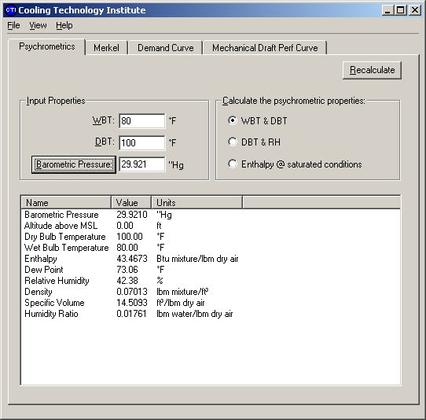

Toggle this button to change to Altitude
MERKEL

The basic function of a cooling tower is to cool water by intimately mixing it with air. This cooling is accomplished by a combination of sensible heat transfer between the air and the water and the evaporation of a small portion of the water. This type of heat transfer is represented by the equation:

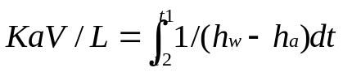

Where: KaV/L is a dimensionless heat transfer coefficient
t1 is the temperature of the entering (or hot) water
t2 is the temperature of the leaving (or cold) water
h_{w} is the enthalpy of the of the saturated air film at the water temperature t1
h_{a} is the enthalpy of the cooling air

This equation is commonly referred to as the Merkel equation, named appropriately for his development of the theory that introduced the concept of enthalpy difference and defines the cooling tower ‘demand’. The derivation of this equation, along with its underlying assumptions, can be found in many texts on evaporative cooling, but most notably, "Process Heat Transfer", by D.Q. Kern, published by McGraw-Hill Book Company in 1950. Another good reference is the CTI paper, “A More Nearly Exact Representation of Cooling Tower Theory (TP91-02)”, by A. E. Feltzin & D. Benton.

From inspection of the Merkel equation, it is apparent that the cooling tower demand is solely a function of the process & environmental variables, not of the cooling tower itself. The reason it is called ‘demand’, is that in order to achieve the desired cold water temperature (t2), the cooling tower must meet the ‘demand’ imposed on it by the process & environmental parameters. This demand is met when the appropriate amount of heat transfer media (fill) is in contact with the appropriate amount of air.

The Merkel Tab performs the KaV/L calculation above by using the four-point Tchebycheff numerical integration scheme*. This equation is also used in the production of the demand curves, which is the basis of the graphical technique of determining the design L/G ratio for cooling towers, once the tower characteristic is known.

*An example of this calculation can be found in paragraph VII of the original Bluebook introduction, located on the CDROM in the ‘Documentation’ directory.

Merkel Tab Usage

The inputs required for the calculation are:

· Entering (or Hot) water temperature, (T1)

· Leaving (or Cold) water temperature, (T2)

· Wet bulb temperature of the incoming air, (WBT)

· Mass ratio of water to air, (L/G)

· Site Barometric Pressure or Altitude

The output of the calculation is the dimensionless grouping ‘KaV/L’, which is a measure of the required duty imposed on a cooling tower.
Toggle this button to change to barometric pressure
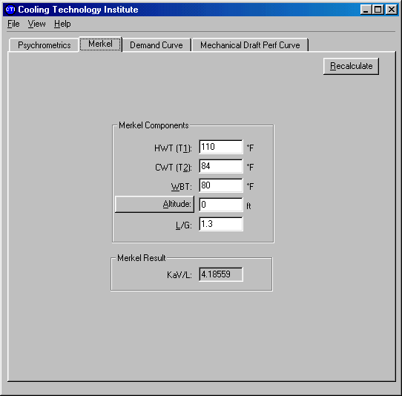
DEMAND CURVE

This tab produces curves of cooling tower demand (KaV/L) as a function of L/G on a log/log plot. Cooling tower demand curves are the numerical solution of the Merkel integral (see Merkel) over a wide range of L/G values.

The Demand Curve application is applicable for use in designing cooling towers, for analysis of test data, and for the prediction of cooling tower performance with changes in operating conditions. It enables the evaluation of the performance of a given cooling tower, within reasonable operating limits, without the necessity of original performance curves. It also allows prediction of performance over a much broader range of operating conditions than the usual performance curves.

Limitations on use of DEMAND CURVE

- Actual tower performance may deviate from predicted at water loadings and air velocities considerably different from design because of the following effects:

  - At very low water loadings (than design), the nozzles will no longer distribute water to the fill evenly, leaving dry areas.
  - At very high water loadings (than design), the nozzles may throw water onto nearby vertical surfaces (partition walls and sidewall casing), bypassing the fill altogether.
  - In counterflow towers at very high air velocities, the air may bypass perimeter fill and channel to the center of the cell, increasing overall pressure loss. Also, the bypassed fill will not be effective in cooling its water load.
  - In crossflow towers at very high air velocities, the air will move the water off the fill leaving dry areas.
  - If the water loading varies significantly from design, the airflow will change since tower air-side resistance is a function of water loading.

- A single known L/G versus KaV/L point is sufficient for the prediction of performance at various wet bulb temperatures and cooling ranges, if L/G is held constant. If L/G is varied, the tower characteristic curve is used for predictions. In this application the tower characteristic is expressed by two parameters, ‘C’ and ‘Slope’. These are the constants of the expression:

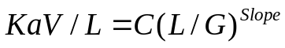

If two test points are known, these constants can be developed mathematically by solving the above equation for C & Slope. If only one point is available, the use of -0.75 as “Slope” will provide reasonable results for towers filled with film fill. Use -0.65 for towers filled with splash fill.

Examples of use of this application is shown in the help section, “Demand Curve Worksheet Example 1: Off- Design Performance example”.

Demand Curve Tab Usage

Entering the values of wet bulb temperature, range, altitude and clicking on ‘Recalculate’ brings up the appropriate group of Demand Curves. These curves represent the solution of the Merkel equation over a wide range of liquid-to-gas ratio’s (L/G’s) and are so called since they represent the demand imposed on the cooling tower by the environmental & process variables and each one represents a specific approach temperature (see glossary).

Clicking on View/Demand Curves brings up the ‘Curve Selection’ dialog box, which allows the selection of the approach curve(s) of interest. Clicking on items in the ‘User Target’ section will display the items listed. The ‘Target Approach’ click box is especially useful since it will draw the intersecting approach curve to a known L/G & KaV/L intersection. The ‘User Approach’ click box allows the drawing of an approach curve of any value.

The section of the worksheet labeled “Tower or Fill Characteristic” allows the entering of the fill or tower coefficients ‘C’ & ‘Slope’ as mentioned above. Entering a value of "C" and "slope" and clicking ‘Recalculate’ will display the fill characteristic curve from the selected minimum and maximum.

Entering a value of L/G and clicking on ‘Recalculate’ will display a vertical line at the selected L/G value and intersect the characteristic curve. This intersection defines the approach temperature at the selected L/G ratio. The numerical value of the approach temperature is displayed when clicking on the KaV/L - Approach toggle.

Within the black plot area, the mouse can provide the following useful actions:

- Holding down the left mouse button and dragging down and to the right creates an enlargement box, which when released will zoom to fill the plotting area. Clicking on ‘Recalculate’ will return the plot to normal.

- Positioning the mouse pointer over any curve intersection (or any location in the plot area) will return the KaV/L, L/G and approach value for that location.

- Holding down the right mouse button and dragging will pan the curves left or right, up or down.

- Double-clicking on or near a demand curve will delete it from the plot area.

New with version 4.0 is the ability to save data and retrieve previously stored data files. To save data, first click on the down arrow and click on, “New Data File”. This brings up a dialog box, which allows you to enter a file name. Once entered, click on ‘OK’. Clicking on ‘Save’ saves the current work sheet data.
KaV/L – Approach toggle
Toggle this button to change to barometric pressure
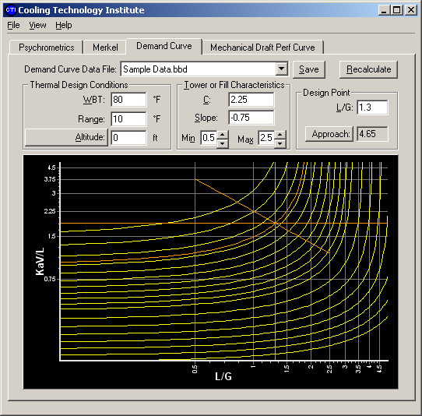
Mechanical Draft Perf Curve

The Cooling Technology Institute publishes its cooling tower test standard ATC-105 to standardize the testing of all types of cooling towers. This standard describes in detail the test methodology as well as the procedures to evaluate the collected data to determine the cooling tower capability. There are two methods for determining tower capability from collected test data: the characteristic curve method and the performance curve method. The characteristic curve method can be performed using the Demand Curve tab, along with appropriate data supplied by the manufacturer and field test data. The performance curve method can be performed using the Mechanical Draft Perf Curve tab, along with a set of performance curves supplied by the tower manufacturer or rebuilder and field test data.

New with Version 4.0:

This application is now designed for all types of mechanical draft cooling towers; crossflow & counterflow, induced draft & forced draft.
Mechanical Draft Perf Curve Tab Usage

The performance curve method allows the evaluation of test data using a set of manufacturer’s performance curves. For this tab application, the curves must conform to the ATC-105 specifications, i.e., minimum of 3 flows (for example, 90%, 100% and 110% of design), 3 ranges (for example, 80%, 100% and 120% of design) and at least three, but no more than six, wet bulb temperatures (it is preferred that one of the points be the design wet bulb temperature). The calculation proceeds by intersecting the performance curves first at the test entering wet bulb temperature, then the test cooling range, and finally the test leaving water temperature. All interpolated points are determined using smooth fitting cubic spline curves through the original data points and the two successive cross plots to arrive at the ‘Predicted Flow Rate’ at test conditions.

The Adjusted Test Flow rate is the test water flow rate adjusted for the difference between the actual fan motor output power and the design fan output power as well as the test vs. the design air densities. The test flow must be adjusted for air densities since ATC-105 specifies that performance curves shall be based on constant fan pitch angle. This means that as the air density increases (i.e. at lower wet bulb temperatures) a constant pitch fan (and constant speed fan) WILL increase fan power proportionally to the density change. The adjusted test flow rate compensates for this density effect on the motor output power.

The overall Tower Capability is the Adjusted Test Flow Rate divided by the Predicted Flow Rate.
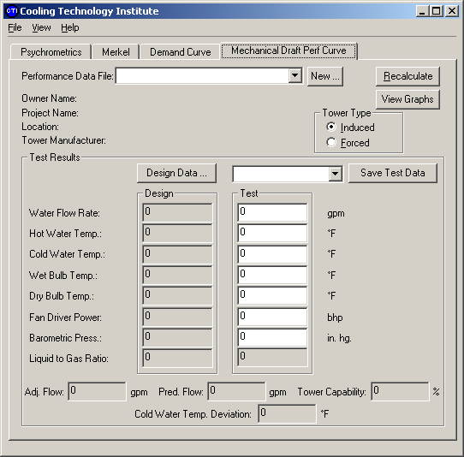
Opening Screen for Mechanical Draft Perf Curve Tab

This application has two data entry screens that are used for the entering of the design, test & curve data. The opening screen (the one that comes into view when the performance curve tab is selected) is the main worksheet. Click on the various data and control areas of the screenshot below to see help text on each.

The best way to familiarize yourself with this application is to load one of the examples that came with this program. These examples correspond to the examples in the ATC-105 Appendix C for SI data and Appendix D for IP (inch-pound) data. To access these files, click on the down arrow next to the 'New" button on the performance curve opening screen (see illustration below).

New for Version 4.0

There are three significant additions to this application for Version 4.0.

- The inclusion of forced draft (FD) cooling tower performance analysis.
- The calculation of Cold Water Deviation. This value represents the cold water temperature that would be expected if the cooling tower were operated at its exact design conditions in its tested physical condition.
- The direct copying of the crossplots into word processing or spreadsheet applications.

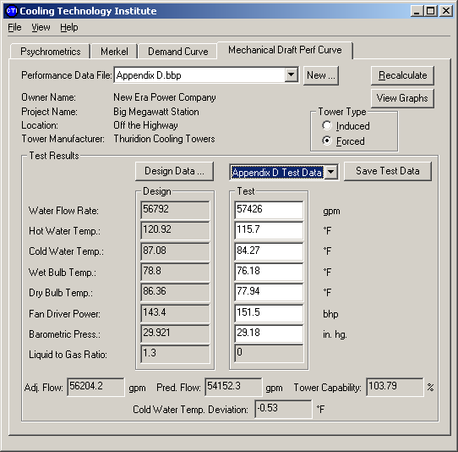
New for Version 4.0
New for Version 4.0
Mechanical Draft Perf Curve Tab: Entering Data for the First Time

First time data entry is a manual process.

- Click on the "New" click button. The "New Performance Data File" dialog box will come up allowing you to enter a unique file name for the data set. Clicking the down arrow on the box labeled "Based on:" will allow you to use an existing data set as a basis for the new one.

- Next click on "View Design Data" to bring up the "Tower Design Data Screen". This is the screen where performance curve data is entered (see the screenshot below). Clicking on the various data areas will pop up definitions.

- Enter the project information in the area called "Tower Information", and enter the design data in the area called, "Tower Design Specs".

- Enter curve data in the area called, "Tower Design Curve Data". This data can be read from a set of performance curves, or may be supplied as discrete points in a data file or in a spreadsheet. If the latter is the case the data can be accessed in the appropriate application (spread sheet, word processor or text editor) and cut and paste point-by-point into the data fields. Click "OK" when all data is entered.
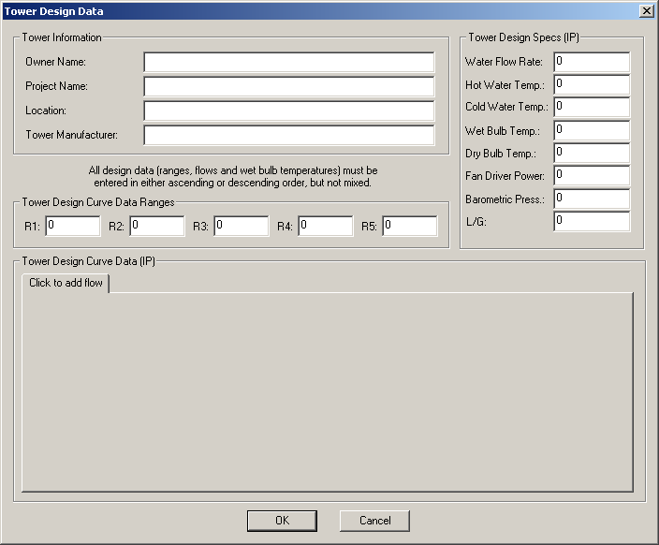
Performance Curve Tab: Using Existing Project Files

Once a data file is created, it can be easily accessed for later evaluation. Or, if a data file is prepared by a third party (for example, a manufacturer or rebuilder may provide the performance curves in this format) it can be accessed and test data entered for quick evaluation.

- Click on the down arrow just to the left of the "New" button and select the project file to be accessed.

- Click on the down arrow to the left of the "Save Test Data " button and select "New Test". This will bring up the "New Test" Dialog box allowing the new test data to be named. Enter a descriptive name (a test date and time may be appropriate) and click "OK".

- Enter the test data in the appropriate data boxes. The tab key allows you to quickly move from one data box to the next facilitating data entry. When complete, click on "Save Test Data" to store the data.

- Click on "Recalculate" to compute the tower capability.
Performance Curve Tab: Viewing the Graphs

Once the data is entered and the calculation is complete you may wish to view the graphs.

- Click on View Graphs button.

- There are tabs for each of the flows plus two cross plots.

- Click each tab to view the specific graph. Each graph can be viewed or enlarged in any specific area. Superimposed on each flow graph is a vertical line that represents the test entering wet bulb temperature. These graphs can be viewed on the screen and copied to word processing or spreadsheet applications by clicking on “Copy”.

- Cross plot 1 shows predicted leaving water temperatures at the various flows based on the test entering wet bulb temperature vs. test cooling range.

- Cross-plot 2 shows the predicted flow based on the test entering wet bulb temperature, test cooling range and test leaving water temperature. The horizontal line at the test leaving water temperature intersects the curve and yields the Predicted Flow rate. The predicted flow rate is the waterflow that the tower can cool to the test leaving water temperature at the test entering wet bulb temperature, test range.
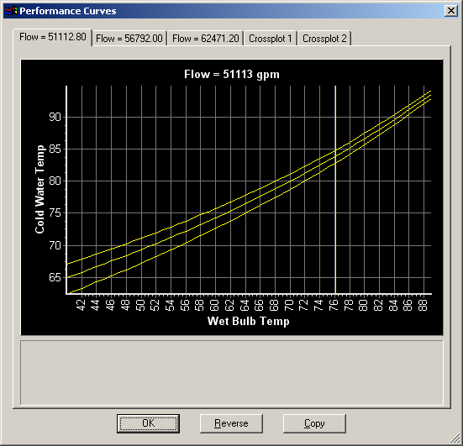
New for Version 4.0
New for Version 4.0
Performance Curve Tab: Printing the Report

Once the data is entered and the calculation is complete you may wish to make a hard copy print of the report.

- Click on the "File" drop down box in the upper left of the screen and select print set-up.

- Select the printer, paper and select portrait orientation. Click on "OK".

- Again select "File" and select the "Print Preview" option.

- If all is ok, then close the print preview window & select “Print” from the “file” drop down menu. You have the option of printing the performance report or the design data report.

To print to a file for later printing or inserting into reports you can create a generic printer by using the Windows "Add Printer" dialog box accessed by clicking on the Start Button and clicking on "Settings" and then "Printers". The procedure will differ depending on which version of Windows is being used. Once the generic printer is selected, click on "print to file". Once the set up wizard is complete, right mouse click on the new printer you just created and select it as your default printer.

New for Version 4.0

Printing the graphs with black lines on white background can be done now by clicking on the button, ‘Reverse’ on the graph window. Once reversed, click on ‘copy’ to place the graph in the clipboard. Now the image can be pasted directly into any word processor or spreadsheet application.
New for Version 4.0: Optional reversed image for pasting into word processors & spreadsheets
